**Assignment 2**

**Due Date: 18 Dec 2017 11:59pm (late or not submission will be 0%)**

**Assessment: /100 (15% of your total grade)**

**Instruction: Group work (maximum 4 team members for one team)**

1. **Objective**

* Using HTML, JavaScript and Bootstrap for manipulating node.
* Become familiar with the DOM paradigm.

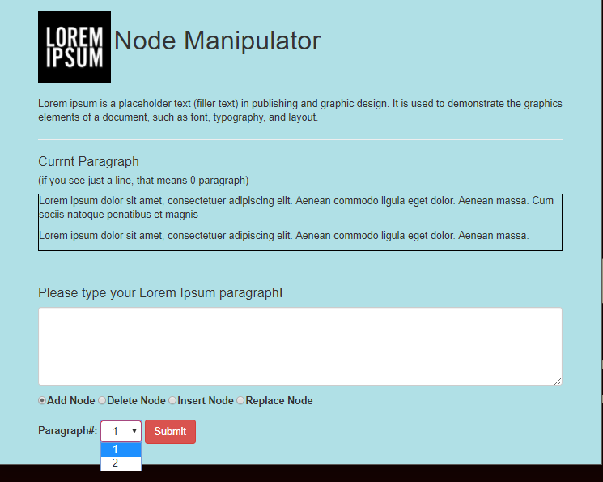

Paragraph 2

TextArea for INPUT

Dropdown button

Paragraph 1

1. Description

You are required to write a HTML/JavaScript program, which has 4 functionalities for manipulating nodes (add, delete, insert and replace node).

1. Add : this function can add paragraph
2. Delete: this function can delete specific node by user
3. Insert Node: this function can insert specific location by user
4. Replace : this function can switch specific nodes by user
5. Drop down button can choose the paraph
6. Hints and Guide lines

***Add:***

1. Get value from textarea
2. Create text node (use createTextNode())
3. Create element (use createElement())
4. Append child(use appendChild())

***Delete:***

1. Get index from Drop down button
2. Get a paragrah element(getElementByTagName())
3. Remove speciifc node(removeChild())

***Insert:***

1. Get index from Drop down button
2. Get value from textarea
3. Create text node (use createTextNode())
4. Create element (use createElement())
5. Append child(use appendChild())
6. Get index from current paragraph(use item())
7. Put new pragraph specific location(use insertBefore())

***Replace:***

1. Get index from Drop down button
2. Get value from textarea
3. Create text node (use createTextNode())
4. Create element (use createElement())
5. Append child(use appendChild())
6. Get index from current paragraph(use item())
7. Replace old paragragh with new paragraph(use replaceChild())

**Rubrics**

**Task1(Web Design): [30pts]**

HTML design - 15Pts

CSS or Bootstrap – 15pts

**Task2(Programming Fundamental): [30pts]**

JavaScript Event handing – 10pts

External JavaScript link – 10pts

Comment -10pts

**Task3 (Node Manipulating): [40pts]**

Add - 10Pts

Delete - 10pts

Insert- 10pts

Replace -10pts